

**USE OF THE SUPER BEAST SERVICE CONDUCTOR TESTER (HJA-469-D)**

1. **GENERAL**

This work method describes the use of the “Super Beast” Service Conductor Tester by H.J. Arnett Industries.

The Super Beast is a conductor tester used to apply up to 20 amps load on 120 volt service to determine if one or both of the conductors are open (or partially open), as well as verifying the condition of the neutral conductor. There are many reasons why a service may not be providing maximum voltage to the customer including a faulted cable, loose connection or some other resistive condition.

The Super Beast is a self-contained, fully portable device which can be used to load transformers and service conductors for diagnostic testing.

1. **HOW THE SUPER BEAST WORKS (from the Super Beast Service Conductor Tester manual)**

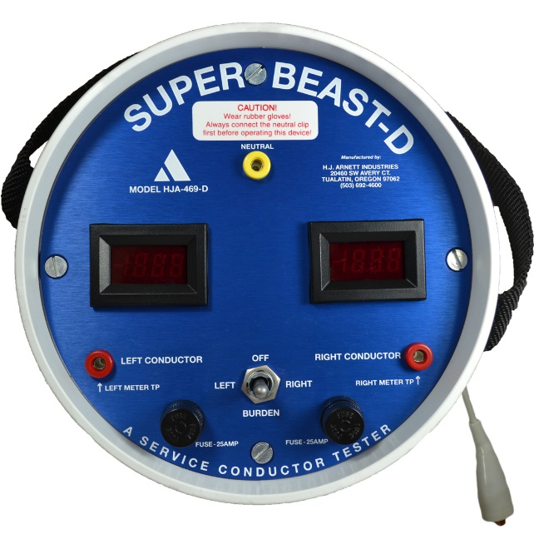

* 1. For each position of the “burden switch” (left, center, right) different readings appear on the meters based on the condition of the conductors. The selected meter may drop (usually only a couple of volts for conductors in good condition) due to the load being put on the transformer. The Super Beast will read as below when connected to “good” service conductors.

|  |  |  |  |
| --- | --- | --- | --- |
| **Switch Position** | **Load (Burden)** | **Left Meter** | **Right Meter** |
| Centre | OFF | 120 volts | 120 volts |
| Left | ON | 120 volts | 120 volts |
| Right | ON | 120 volts | 120 volts |

The Super Beast will read as below when connected to an open neutral.

|  |  |  |  |
| --- | --- | --- | --- |
| **Switch Position** | **Load (Burden)** | **Left Meter** | **Right Meter** |
| Centre | OFF | 120 volts | 120 volts |
| Left | OFF | 0 volts | 240 volts |
| Right | OFF | 240 volts | 0 volts |

The Super Beast will read as below when connected to an open “hot” service conductor.

|  |  |  |  |
| --- | --- | --- | --- |
| **Switch Position** | **Load (Burden)** | **Left Meter** | **Right Meter** |
|  | **Open Right Conductor** | |  |
| Centre | OFF | 120 volts | 0 volts |
| Left | ON | 120 volts | 0 volts |
| Right | OFF | 120 volts | 0 volts |
|  | **Open Left Conductor** | |  |
| Centre | OFF | 0 volts | 120 volts |
| Left | OFF | 0 volts | 120 volts |
| Right | ON | 0 volts | 120 volts |

1. **OPERATION (from the Super Beast Service Conductor Tester manual)**
   1. Remove the KWH meter. Always wear your personal protective equipment (PPE) and follow Standard Work Method.

* If the meter base is deteriorated and meter cannot be removed safely, then the first test can be made at the weather head on the meter side of the service connections
  1. Inspect the meter base for loose connections or any other observable problems. First connect Green to neutral, and then insert Super Beast in the meter base.
  2. Turn the burden switch to the LEFT position and record each step in Appendix A.
  3. Repeat with the burden switch in the RIGHT position.
  4. Compare recorded readings (for burden switch in LEFT position) with the table below for analysis of results. Readings will not be exactly as shown.
* 110 V to 125 V – Normal range
* 106 V to 110 V and 125 V to 127 V – Extreme operating conditions, improvement work should be taken on a planned basis
* <106 V or >127 V – Outside the extreme range therefore should be escalated to more immediate fix.

|  |  |  |
| --- | --- | --- |
| **Left Meter** | **Right Meter** | **Indication** |
| 120 | 120 | Left meter reads 120V, so left conductor is good |
| 85 | 120 | Only left meter drops, so left conductor is partially open. If left meter goes blank, left conductor is fully open. |
| 90 | 150 | Left meter drops, right meter increases, so neutral is open. These readings represent a partial open. If left conductor goes blank and the right meter reads 240V, then the neutral is completely open. |

* 1. Compare recorded readings (for burden switch in RIGHT position) with the table below for analysis of results.

|  |  |  |
| --- | --- | --- |
| **Left Meter** | **Right Meter** | **Indication** |
| 120 | 120 | Right meter reads 120V, so right conductor is good |
| 120 | 85 | Only right meter drops, so right conductor is partially open. If right meter goes blank, right conductor is fully open. |
| 150 | 90 | Right meter drops, left meter increases, so neutral is open. These readings represent a partial open. If right conductor goes blank and the left meter reads 240V, then the neutral is completely open. |

* 1. Complete the description of service table at the bottom of Appendix A.

1. **3-PHASE APPLICATIONS**
   1. The Super Beast can be used effectively on 120/208 volt 3-phase Wye systems using a portable meter base adapter (HJA-469-500) as seen below.

1. Connect clips of the adapter to neutral, line 1 and line 2.

2. Take readings on Line 1 and Line 2.

3. Move one clip lead from either line 1 or line 2 to line 3.

4. Take readings again.

Results can be interpreted the same as for single phase operation.

1. **CAUTION (from the Super Beast Service Conductor Tester manual)**
   1. This tool is **not** to be used on 120/208 volt 3-phase 4-wire Delta because 208 volts are present between ground and “high phase” of the 3-phase 4-wire Delta system.
   2. This tool is NOT to be used on 347/600V systems.
2. **PIN-POINTING SOURCE OF TROUBLE**
   1. Refer to sketch below to indicate locations at which the Super Beast is typically installed in sequence in order to pin-point source of trouble (high impedance connection).
      1. Begin at Meter Base if possible (if doubtful that meter can be removed safely, then check at meter base side of service connections at location 2 )
      2. If test 1) above gives bad readings, then attempt to locate source of high impedance by moving backwards sequentially until Super Beast no longer sees the ‘ BAD connection ‘. This will typically begin at location 2, on the source side of the service connections.
      3. If step 2) also shows the problem, then move to the next set of connections, possibly at location 3) to test, again on the source side of these connectors.
      4. Proceed accordingly until you are at the transformer leads themselves for testing.
   2. Once the location has been determined, then change out all connections at this one location preferably and return to step 1) above to confirm solution.

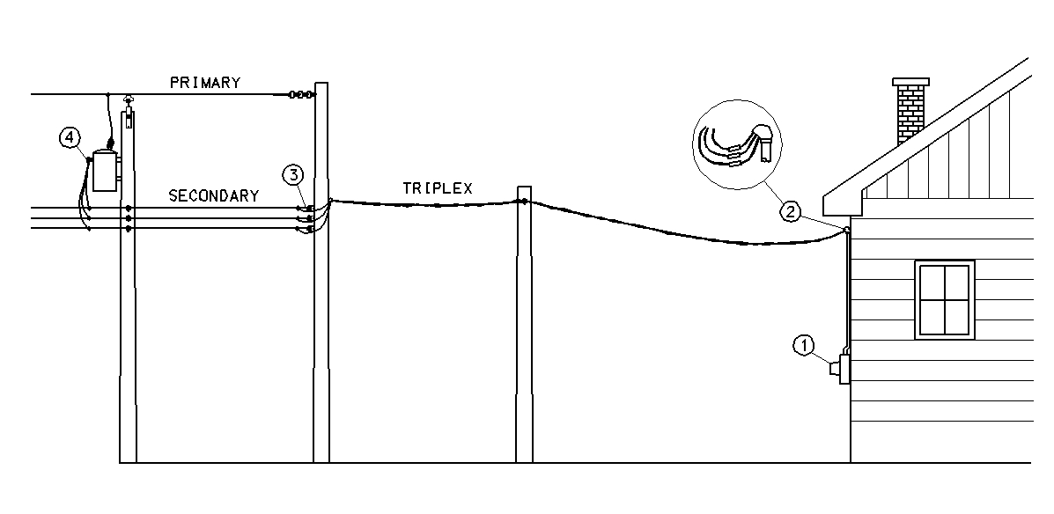

**APPENDIX A**

**Super Beast Meter Readings:**

(Table to record your readings, record voltages from digital meters on Super Beast)

|  |  |  |
| --- | --- | --- |
| **Left Meter** | **Right Meter** | **Condition** |
|  |  | **Switch in LEFT position** |
|  |  | **Switch in RIGHT position** |

**Description of Service:**

|  |  |  |  |  |
| --- | --- | --- | --- | --- |
| **Transformer KVA rating (KVA)** | **Transformer Secondary Voltage (V)** | **Distance from Transformer** | **Type of Conductor** | **Number of customers on Transformer** |
|  |  |  |  |  |

(Table to record a brief description of the service being tested)